Experimental Method
CVD synthesis of MoS₂/WS₂ heterostructures was performed in a double zone CVD furnace as shown in the schematic diagram in figure 1. 10 mg MoO₃ (99.9% purity, Sigma- Aldrich) and 25 mg WO3 (99.9% purity, Sigma- Aldrich) mixed with 1 mg NaCl (99.5% purity, Sigma-Aldrich) were placed two separate alumina boats at around 1.5 cm apart. A thermally oxidized silica substrate cut in to 4 cm x 1.8 cm rectangular dimension and cleaned through ultrasonication in acetone, IPA and deionized water for 15 minutes each and dried with high pressure nitrogen was placed upside down on the boat containing WO3 with leading edge just above WO₃+NaCl precursor. This boat and another boat containing 500 mg S (99.9% purity, Sigma- Aldrich) were placed inside a quartz tube of inner diameter 44 mm and length $\sim$ 1 m. The boat containing sulfur is placed in the upstream region of the tube in the outer edge of the heating zone to avoid premature evaporation before the growth temperature was reached, about 18 cm from the boat containing metal oxide which is placed at the center of the heating zone.

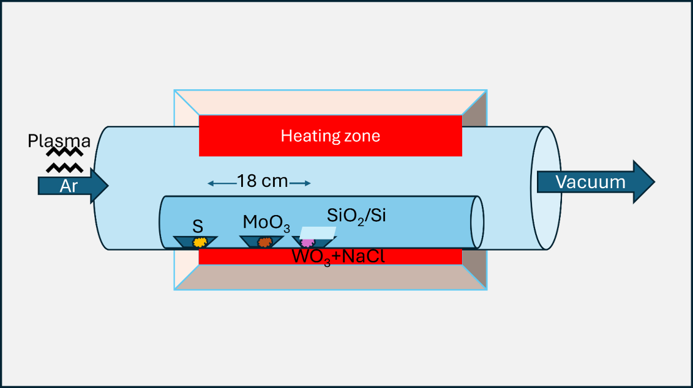
Fig.1: Schematic diagram of CVD synthesis of MoS₂/WS₂ heterostructure on SiO₂/Si substrate.

The sulfur containing boat was placed at $\sim$45 cm from plasma source which generated argon plasma using a VERG-500 power generator with 13.56 MHz frequency. Plasma power varied between 0 W and 200 W and was ignited 10 °C prior to reaching the primary growth temperature and maintained throughout the entire growth period. Argon was also used as the carrier gas due to its non-reactive nature. The argon flow rate was fixed to 50 SCCM (standard cubic centimeters per minute) with an initial process pressure of ∼700 mTorr which would normally increase up to 900 mTorr when maximum growth temperature has reached. Prior to growth, the tube was purged with 500 SCCM nitrogen gas, and then allowed to sit at 300 °C under argon flow for 10 min. The sample was then heated to the growth temperature of 780 °C at a rate of 13.75 °C/min. The growth time was fixed to 15 min. Throughout this period, the temperature of the crucible containing sulfur was maintained at or below ~180 °C by manually moving the furnace slightly towards or away from sulfur containing boat. Following growth, the top cover of the heating element was removed, and a fan was used for rapid cooling to room temperature under continuous flow of argon.

